Penn State Commons Desk Clerk:
Simple How to Guide to Mail Forwarding

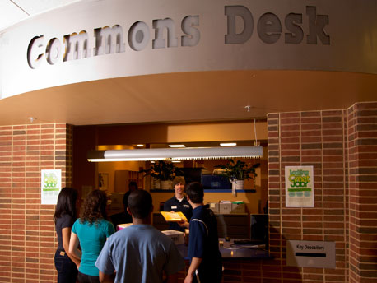
Penn State Commons Desk Operations
http://www.housing.psu.edu/housing/housing/commons.cfm

Gaston Moliva

Introduction
Over the course of an average work year, mail forwarding has proven to be among the most common and frequently demanded tasks expected of a Commons Desk Operations Clerk. It is therefore crucial that all employees be properly trained and equipped with the proper tools and knowledge to carry out all procedures quickly and efficiently. In a perfect world, all mail and packages sent through the Commons Desks would arrive correctly labeled and addressed to the students and staff residing in that area. However, with six Commons Desks dispersed throughout campus and thousands of students moving between residence hall, moving off campus, graduating, or simply deciding to leave on-campus housing or the school together… it is anything but perfect. Desk Clerks will sort through the mail and packages and direct them to their properly designated areas. Forwarding comes into play primarily when mail is sent to an address that does not match the corresponding resident currently living in the room. This is when a Desk Clerk is expected to recognize what type of mail they are working with and follow up with the correct procedure in order to forward it on to its intended recipient.

Glossary
First Class: A class of mail that can include postcards, letters and USPS Priority Mail. Most types of mail can be sent through First Class.

Address Correction Requested: Used in forwarding and returns, a new separate address notification is provided.

Temp Service Requested: Only available for First-Class mail, for forwarding in cases of temporary changes of address.

Forwarding Service Requested: For forwarding and returns when new address notification is provided.

Bulk Rate: When a large volume of mail has been shipped in bulk in order to reduce postage rates.

Presorted Standard: A class of shipment that is generally seen in pieces of mail that are generally identical in content to each other, such as in flyers.

Non-Profit: A class of shipment that provides reduced postage rates for nonprofit organizations.

China Marker: A waxy pencil used in crossing out the bar codes on mail when forwarding.

CAUTION: “Bulk Rate”, “Presorted Standard” and “Non-Profit” will sometimes have to be forwarded if there is an address correction requested on the envelope.

Overview
All mail for students no longer residing within the area will be marked as either “First Class”, “Address Correction Requested”, “Temp Service Requested”, “Forwarding Service Requested”, “Bulk Rate”, “Presorted Standard”, or “Non-Profit.
This will indicate to you whether or not the mail will need forwarding. Once this is identified you will proceed with the appropriate steps as follows.

Materials Needed
- Your login information for accessing Penn State eLiving Staff
- China Marker
- Blank White Labels
- Mailer Stamp and Ink Pad
- Pen

Procedure to Forwarding Mail
1. Prepare the mail to be forwarded by crossing off all of the bar codes placed on the mail during the mailing process using a black china marker, NOT black permanent marker. If the bar code is not removed, the Postal Service will route the mail back to the Commons Desk. See the diagrams below for the three most common locations of bar codes that need to be blacked out (marked A, B, and C).

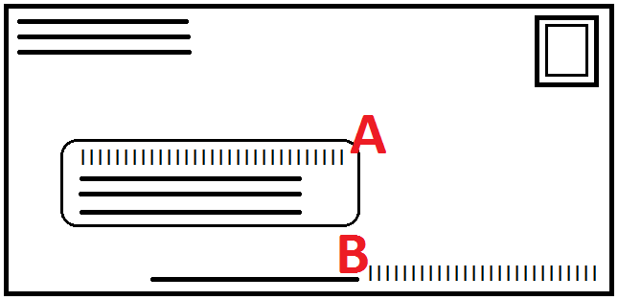
CAUTION: Be sure to check the back of the mail as well, as many letters will include a pale orange bar code on the reverse side, which must also be blacked out.

2. Log into the eLiving staff system, and begin by clicking the Desk Ops tab. Check eLiving for the resident’s current address.

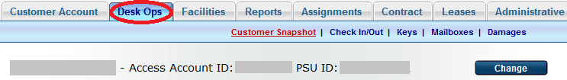

Look up the student using the Change button. If more than one student shares the name in question, use clues such as middle initials with the access account IDs to narrow down the search. After you have located the student, verify if they are currently living on campus at University Park. If so, write the current address (room and hall), and place the mail in the correct mailbox (if it is in the area where the forwarding is being completed) or the manager’s box (if the student is living in another residence area).

3. If the student is no longer living anywhere on campus, click the Customer Account tab, and then click Student Information.

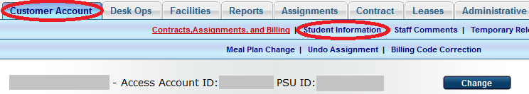

This page includes several pieces of personal information, most pertinent for the topic at hand being the two address fields. Check the “Local Address” field. As long as this address in not an on-campus address, write it in pen somewhere in an open area of the front of the envelope to be forwarded. If the “Local Address” field in an on-campus address, then use the “Home Address” instead.

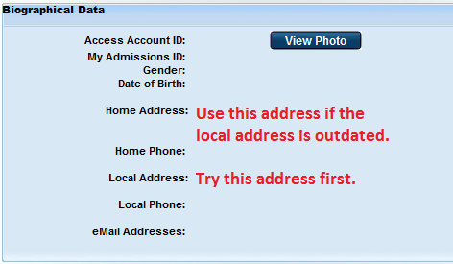
4. At this point, the forwarding process is completed for the piece of mail. Continue following this procedure in steps 1-4 until all the mail has been appropriately forwarded.

5. However, if you are unable to locate an adequate address, the mail is to be stamped “Return To Sender”. Check the appropriate reason for this action (“Attempted Not Known” or “Not At This Address”).

CAUTION: When doing this, be sure that the finger from the stamp is pointing at the address of the sender, not to the address of the receiver. If the mail in not stamped correctly, it will be returned to the Commons Desk.

6. For magazines, follow the above procedure. If an address is found and it is within the residence area, place it in the appropriate mailbox. If the student no longer lives within the area, but you have a forwarding address, check to see if the name of the magazine is hand written on the check-in/check-out card. If it is, stamp the address label with the stamp marked “Notified”. If the name of the magazine is not hand written on the check-in/check-out card, forward by neatly writing the forwarding address on a label, and affix to the magazine.

